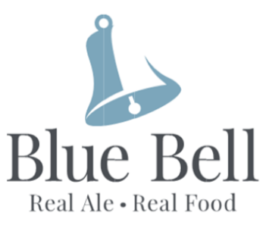
Sunday Lunch Menu
Served 12 till 4.00pm
Tel:- 01423 439405,
email bluebellkirbyhill15@gmail.com

STARTERS
Classic prawn cocktail, with Marie rose sauce (GF/DF/SF) £7.50
Creamy garlic mushrooms and warm crusty bread (GFA/V) £5.95
Breaded French brie, cranberry compote and dressed leaves (V) £5.95
Tempura king prawns, sweet chilli dip and dressed leaves £6.95
Vegetable spring rolls, sweet plum sauce, dressed leaves(V) £5.00 Crispy Belly pork bites, soy, chilli, ginger, honey & red wine sauce with
prawn crackers (DF) £5.95

Sunday Roasts £12.95
Topside of Beef
Leg of Pork with sage & onion stuffing, crackling
Poached Chicken Breast with sage & onion stuffing
Served with Yorkshire Pudding, seasonal vegetables, cauliflower cheese and herb roasted potatoes
& all available Gluten free if required.
Roasts Available as a Smaller Portion £8.50

Mains
Belly pork with crisp crackling skin, apple & cider sauce, mashed potato & vegetables(GF) £12.50
Individual Steak and ale pie, seasonal vegetables, chips or mash & gravy £13.95
Breaded Scampi, hand cut chips, garden peas, lemon wedge(DF) £10.95
Macaroni cheese with garlic bread(V) £9.95
Hunters Chicken with cheese, BBQ sauce, fries and salad(GFA) £11.95

Burgers
6oz chargrilled beef burger with bacon & cheddar £10.95.
Vegan Bangkok Bad Boy Burger, £10.95
Chicken Burger £10.95
Cajun Chicken Burger £10.95
All served in a brioche bun with tomato, crisp lettuce, gherkins & fries

Desserts
Rich chocolate brownie served with chocolate sauce £5.50
Apple crumble served with creamy custard £5.95
Sticky toffee pudding with a rich, sweet caramel sauce, topped with popcorn £5.95
Homemade cheesecake £5.95
Homemade Pavlova, mixed berries and lashings of cream £5.75
Homemade Sherry Trifle £5.95
Hot Chocolate Fudge Cake with vanilla ice cream £5.50

(GF) (GF) gluten free, (DF) dairy free, (SF) contains shellfish, (V) vegetarian, (DFA) dairy free available, (GFA) gluten free available. Please notify your server of any allergies.

